Aviation Accident Investigation based on Model-In-the-Loop simulation
Yijia Xu
Computer Science Department
Iowa State University
Ames, IA, USA
yijiax@iastate.edu

Abstract
In this paper, a new approach is presented to assist Aviation accident investigation. The new approach uses Model-In-the-Loop (MIL) technology to simulate flight accident using data from airport radar or voice cockpit recorder and flight data recorder, i.e. black box. This paper discusses several topics on implementing the simulation model including Aircraft Movement Control system, Flight Angle Control system and Landing Gear Control. Singapore airline 006 accident is simulated on this model and compared with traditional approach. Comparing two approaches, MIL simulation is easier to implement, faster to simulate and costs less on each investigation.

Introduction
Model-In-the-Loop (MIL) simulation is a technology that allows investigator to use the raw model to run simulation instead of compiling the model into an executable binary file. The advantage of using MIL is the code is platform independent and a scope can be dragged to anywhere inside the model to monitor a global or local variable.
MIL simulation consists two parts: aviation software and environment model. The first one is the software that burns into the airplane processor. It can be a whole software system or a part of them. For example, we can take the auto landing software out and simulate the landing algorithm with different wind speed, altitude and airplane weight. The second one is the environment model that describes how different environment factors could affect a plane flying. We can change wind speed, direction or weather to simulate a flying in different environment. The first part of software can be obtained from aviation companies or open source projects. For the second part, the environment model, we will use “FlightGear” [], an open source environment model to simulate the flying process. In order to run simulation, there is one more important thing we need, Flight Data.
Flight data that used to simulate the accident can usually be obtained from the “Black Box”: cockpit voice recorder and flight data recorder. With the flight data recorder, the simulation will more close to reality. However, without the data recorder, we can still simulate the accident empirical by cockpit voice recorder or airport radar data to see if the simulation fits the accident.
In this project, I will show how Singapore Airline 006 collided when taking off at Taiwan Taoyuan International Airport in heavy storm weather. And I will also show how MIL simulation helped aviation accident investigators determine who was responsible to this accident and why the accident happens.

Related Work
Mark and Padfield [] uses a flight simulator in teach and research academia. They use “HELIFLIGHT”, a control room that has the same instrument in real plane cockpit room. The operator in the control room will maneuver the instruments to control the aircraft. In an accident investigation, we need the software to be automatically simulated instead of having an operator in the control room. So, in this project, we will use FlightGear, a flight simulator to virtually display the instruments. Then we will use MATLAB to control the aircraft and simulate the accident.
Motley [] uses FlightGear to simulate and explore the chance of survival of aircraft accidents. But his research only focuses on military aircrafts. Summers, Shaw, Geneste and Barnes [,,] also use FlightGear as the simulator for planetary exploration by aerbots. In this paper, we will simulate an accident of a commercial aircraft. The main difference is a military aircraft has more degree of freedom, more engine power and heavier workloads. So when modeling the Flight Angle Control System, the degree of Boeing 747 can turn is very different than military aircrafts.
Sorton and Hammaker [] thoroughly described how to control FlightGear through TCP/IP protocol. MATLAB Simulink was used to serve as a communication bridge between Simulink and FlightGear. All the control signals are packed in a UDP packet in Simulink Model and then send the packet through TCP/IP protocol. However, their work focuses on how to develop and test an autopilot system. In this project, the same technology will be used to control the simulator. But we will focus on how to use this technology to help aviation accident investigation.

Modeling the Control System
To simulate the accident, there are three components we need to implement, Aircraft Movement Control, Flight Angle Control and Landing Gear Control. The architecture is shown in Figure 1.
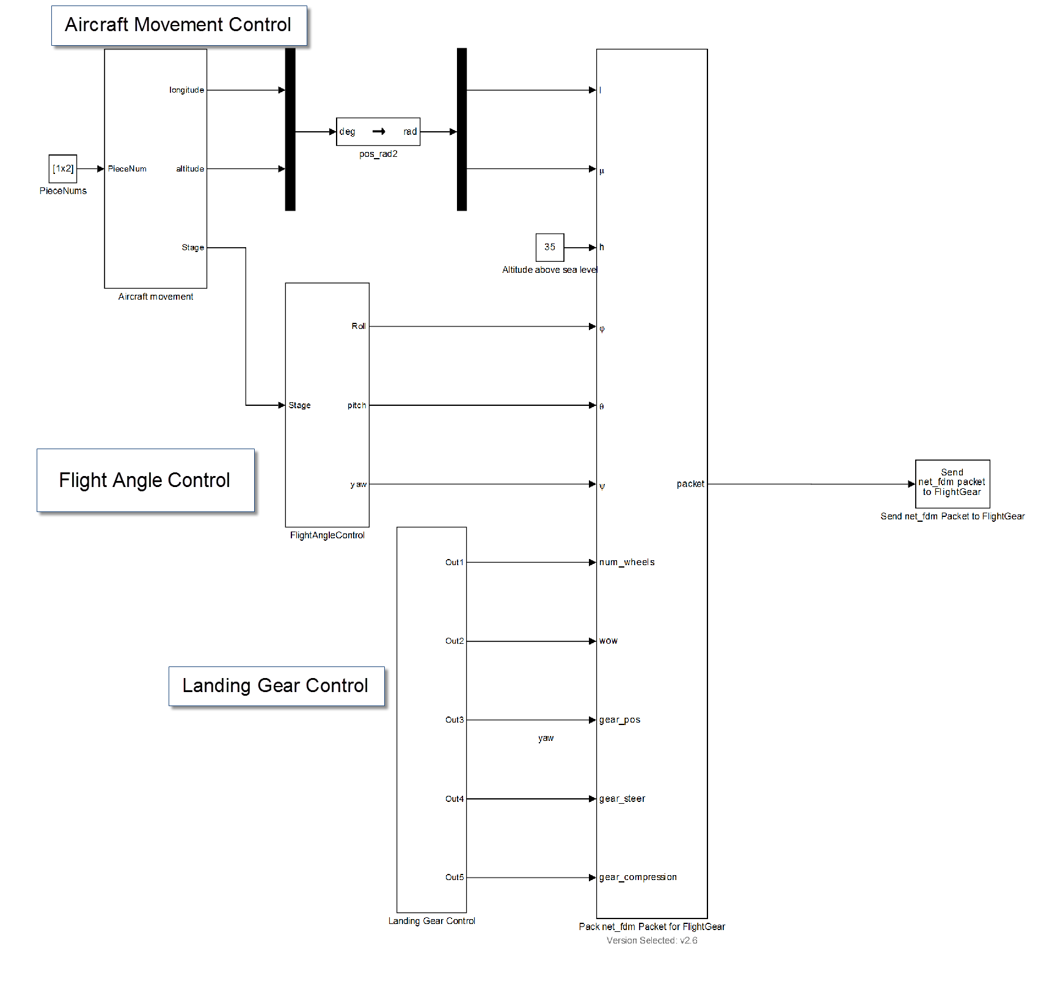
Fig. 1. Model-In-the-Loop system architecture

The Aircraft Movement Control system captures data from flight data recorder and use this data to position the aircraft into the right location. Another crucial system is Flight Angle Control System. Flight Angle Control system calculates flight angles including roll, yaw and pitch from the position sequence Aircraft Movement Control system provided. Landing Gear Control is the easiest subsystem. Since Singapore airline 006 didn’t departure at TaoYuan airport, we keep the landing gear on ground.

Aircraft Movement Control
The “Aircraft Movement Control” subsystem gives the plane a GPS coordinate that it should be located at each moment during the simulation. In this project, since no GPS data is released from Taiwan Aviation Safety Council, I used the information they provided in the accident report [] to calculate the corresponding position.

In the accident report, I obtained the route (shown on Figure 2) and the speed the pilot taxied. According to the route, I obtained two GPS coordinate at the beginning and end of each route from Google Earth. Since the report says, “the plane was taxiing at 5 knots”, The “Taxiing” Stateflow in Figure 3 calculates the position the plane should be at each moment. When the plane reaches route 5, the “Departure” Stateflow will take over and calculate the GPS coordinates.
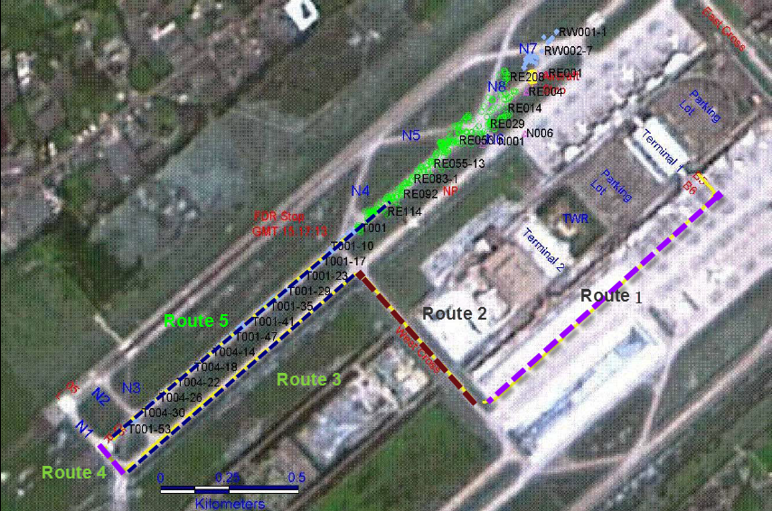
Fig. 2. Singapore Airline 006 taxiing routes

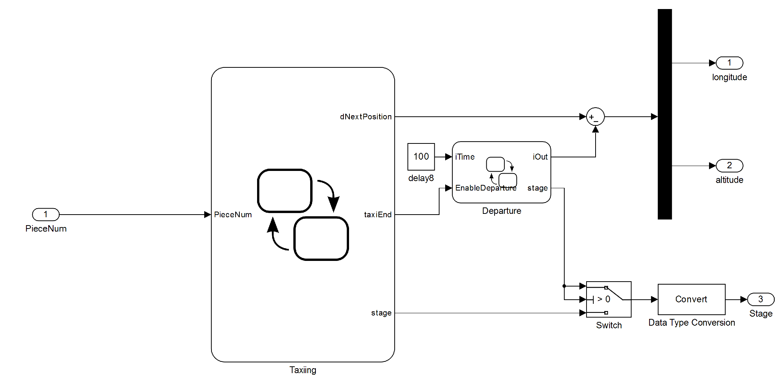
Fig. 3. Aircraft Movement Control subsystem.

Flight Angle Control
In a three dimensional coordinate system, we can define the orientation of the aircraft by the offset from the principle axis. Figure 4 shows the definition of the three motions: Pitch, Yaw and Roll.
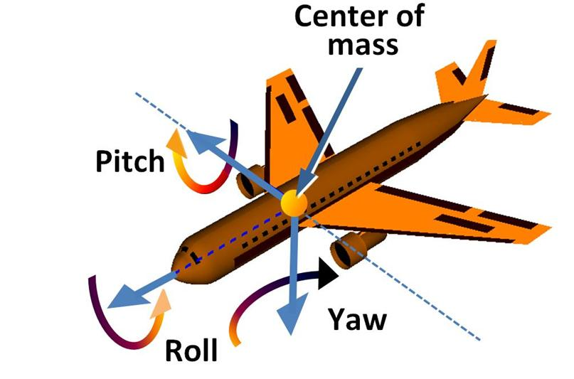
Fig. 4. The definition of Pitch, Roll, Yaw

In the Singapore airline 6 accident, the plane never left the ground, so the roll and pitch remain constant. The only angle we need to change is Yaw. Figure 2 shows the route Singapore airline 6 taxied through. The yaw changes when the plane makes a turn.

In order to simulate the yaw changes, there is a 1D look-up table which calculates the yaw the plane need, and the “ramp” Stateflow simulates how a pilot does the yaw change. Figure 5 shows the inside of the “Flight Angle Control” subsystem.
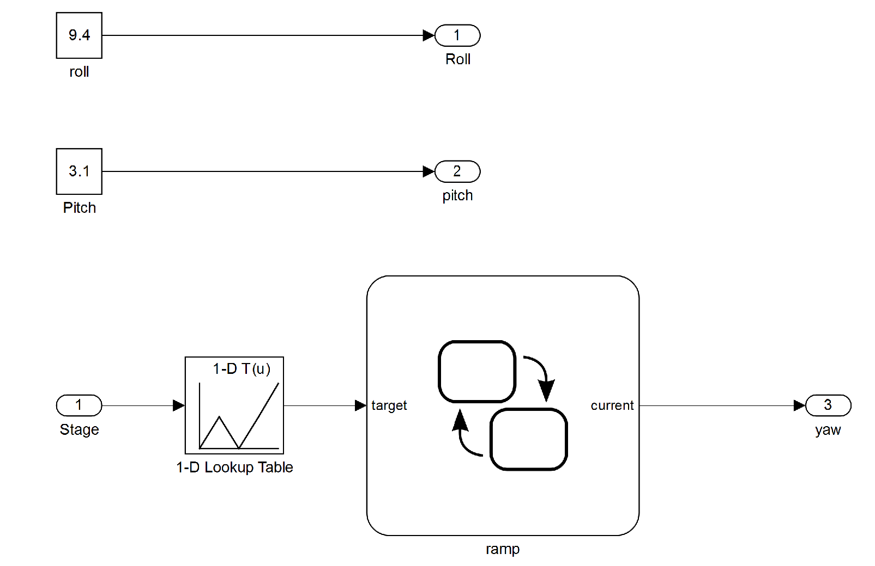
Fig. 5. The inside of the “Flight Angle Control”

Landing Gear Control
The landing gear subsystem has five parameters. Since the plane collided during departure, the landing gear is always deployed. So the parameters are five constants. Table 1 shows the value of the meaning of the parameters and their constant value.
Table 1 Landing Gear constants
Parameter | Description | Value
num_wheels | Maximum number of wheels | 3
wow | weight on wheels signal | [1,1,1]
gear_pos | Landing gear position | [1,1,1]
gear_steer | Landing gear steering angle | [90,90,90]
gear_compression | Landing gear compression | [100 100 100]

Evaluation

The speed of MIL simulation
In real world testing or Hardware-In-the-Loop (HIL) test, there are actual sensors working and simulating the scenarios. In this case, one second simulation takes one second because that’s the time it needs to fetch data from physical sensors. In the MIL tests, every sensor has a model, i.e. all sensor data are calculated by equations instead of waiting for data coming from physical sensors. In a MIL test, the time needs for a simulation is mostly limited by how fast the computer can compute. In this project, an Intel Core i7-3630QM is used for simulation, the maximum speed could reach 10 times faster than real world simulation.

The advantage using MIL simulation is, to actually reproduce the scenario, a real world simulation might take a long time but in MIL simulation, it takes only seconds. In Figure 2, the routes draw in the picture is the taxiing route Singapore Airline 6 flew before collision. Table 2 shows the difference between using real world simulation and MIL simulation. MIL (5X) means the model accelerate its simulation by 5 times, MIL (10X) means the model accelerate its simulation by 10 times.

Table 2. Time consumption of three different simulations
Route | Real-world Simulation | MIL simulation (5X) | MIL simulation (10X)
Route 1 | 4 minutes 28 seconds | 53 seconds | 27 seconds
Route 2 | 4 minutes 56 seconds | 59 seconds | 30 seconds
Route 3 | 7 minutes 20 seconds | 1 minute 20 seconds | 50 seconds
Route 4 | 1 minute 40 seconds | 20 seconds | 10 seconds

Authenticity of Simulation and Accident Investigation
On page 61 of the aviation accident report [4], it says “The taxiway was equipped with both green taxiway center lights and blue taxiway edge lights.” and on page 120, it says “The green taxiway centerline lights that led to Runway 05L on Taxiway N1…” Figure 6 shows the simulation result looks exactly the same as the report describes.
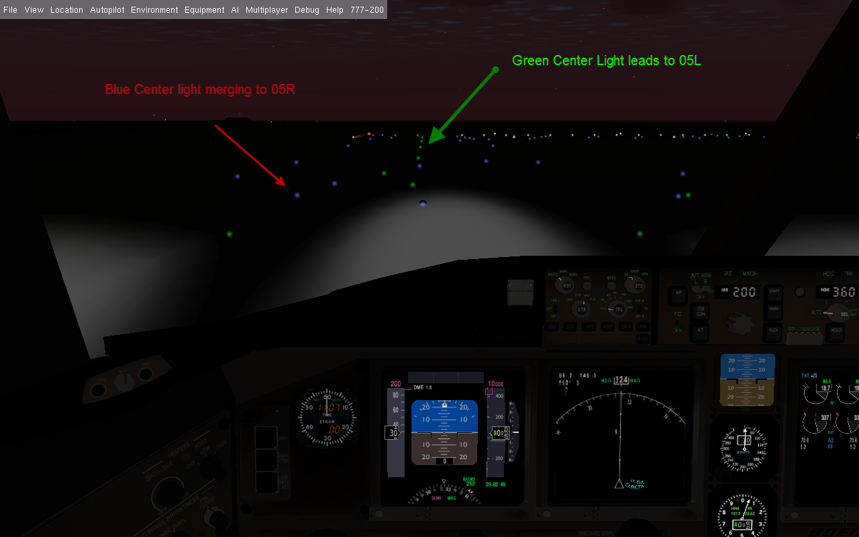
Fig 6. Runway center lights

During the simulation, we found the flight followed the blue light and entered the 05R instead of 05L. The simulation shows the main fault is the pilot followed the wrong center light and led the flight to the wrong runway. The simulation result complies with the investigation report.

The advantage of using MIL
The crucial part of aviation accident investigation is obtaining and analyzing the data from voice and flight data recorder. Now with MIL technology, even without the data, we can obtain plane GPS data from airport radar and simulate it with FlightGear. Once we have the visual, we can determine that the main cause of Singapore 006 is because the flight went into the wrong runway.
Another benefit is MIL simulation is really easy to deploy. Comparing to [1], only a computer is needed for simulation. Also the data needed for simulation is flexible. In Singapore 006 accident, only data from radar is required. By running a MIL simulation, the accident investigator can have a quick look on what happened. And the simulation can give them a clue on which part might have gone wrong.
MIL simulation can be applied to all aviation accident caused by software or human errors. Besides Singapore Airline 006 accidents, Mexican Airline 498 accident [] and Cali accident [] can also be simulated on FlightGear easily.

Conclusion
MIL simulation is rapidly faster than replay the scenario in real world. A 15 minutes real world scenario only takes 2 minutes to simulate on MIL model. The comparison between real-world result and the simulation result reveals that Model-In-the-Loop simulation can accurately reproduce what happens in a real aviation accident.
A Model-In-the-Loop simulation can help the aviation accident investigation better because we can simulated the accident in different condition by change the environment factor, including wind, weather or barometric pressure to see if the accident would happen in other condition. Accident simulation in real world might not be possible due to weather condition but in MIL simulation, all parameters are adjustable. Also to simulate the accident in the real world, the runway must be shut down for safety reasons. This could cause tremendous cost.
In airplane companies, thousands tests need to be passed before a software can be released. Most test cases are generated by automated tools or manually designed by software engineers. A real world accident can be used in software testing and compensate dynamic code analysis.

Reference

- Basler, Michael, et al. "The FlightGear Manual." The FlightGear Manual (2010).
- White, Mark D., and Gareth D. Padfield. "The use of flight simulation for research and teaching in academia." Proceedings of the AIAA Atmospheric Flight Mechanics Conference. 2006.
- Motley, Elizabeth B. Aircraft Accident Survivability: Rotary Wing Aircraft. NAVAL AIR WARFARE CENTER AIRCRAFT DIV PATUXENT RIVER MD, 2005.
- Shaw, Andy, and Dave Barnes. "Landmark recognition for localisation and navigation of aerial vehicles." Intelligent Robots and Systems, 2003.(IROS 2003). Proceedings. 2003 IEEE/RSJ International Conference on. Vol. 1. IEEE, 2003.
- Berndt, Jon S., "JSBSim: An Open Source Flight Dynamics Model in C++," AlAA Modeling and Simulation Technologies Conjerence and Exhibit, AIAA Paper 2004-4923, Providence, RI, August 2004.
- Summers P., Barnes D.P., Shaw A., "Determination of Planetary Meteorology from Aerobot Flight Sensors", 7th ESA Workshop on Advanced Space Technologies for Robotics and Automation, ASTRA 2002. ESTEC Noordwijk, NL, November 2002.
- Sorton, Eric F., and Sonny Hammaker. "Simulated flight testing of an autonomous unmanned aerial vehicle using flightgear." Arlington, VA, AIAA7083 (2005).
- Council, Air Safety. "Aircraft Accident Report: Crashed on a Partially Closed Runway during Takeoff, Singapore Airlines Flight 006, Boeing 747-400, 9V-SPK, CKS Airport, Taoyuan, Taiwan, October 31, 2000." Retrieved May 14 (2002): 2011.
- Andrews, J. W. "Modeling of air-to-air visual acquisition." Lincoln Laboratory Journal 2.3 (1989).
- Civil, Aeronautica. "Aircraft accident report: controlled flight into terrain, American Airlines flight 965, Boeing 757-223, N651AA near Cali, Colombia, December 20, 1995." Bogota: Aeronautica Civil (1996).

